Locating an ideal Neighborhood for Small Business in Atlanta, GA

# Introduction: The (Small) Business Problem

The objective of this analysis is to find relatively safe and potentially profitable location in the city of Atlanta, GA to start a small business. Venues for small businesses such as restaurants, sports bar, coffee shops, saloon or a spa will be explored. Small business entrepreneurs who are considering opening such venues will be target audience for this report.

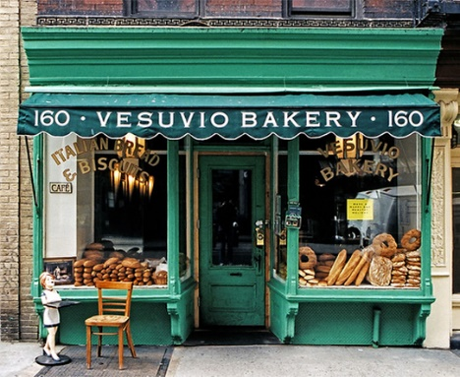The report will try to make a recommendation to identify locations by analyzing key statistics such as crime reports, demographics, such as income, population and real-estate values from datasets made available city’s government (APD, 2020) (City of Atlanta, 2020).

Since the target audience are small entrepreneurs to reduce the startup costs, report will try to use publicly (for free to public) available government sources to make location recommendations. Analysis of these datasets will help provide key insights to make informed decisions such that the business is in relatively safe neighborhood and can provide higher business turnover.

The analysis does not assume the individual has a specific venue in mind but will provide several options from the information available from the analysis.

The analysis will aim to provide key insights to potentially avoid leading causes of what causes a small business to fail in their initial year of startup (Otar, 2018).

# References:

Atlanta Police Department (APD)(2020). Crime Statistics- Crime Data Downloads [Data Set]. APD. https://www.atlantapd.org/i-want-to/crime-data-downloads

City of Atlanta- Department of City Planning (2020) *NPU* [Data Set]. City of Atlanta. https://dpcd-coaplangis.opendata.arcgis.com/datasets/npu

City of Atlanta (2020). *Office of Zoning and Development- Population - 2017 Census Estimates by NPU.* City of Atlanta. https://www.atlantaga.gov/government/departments/city-planning/office-of-zoning-development/population

Otar, C. (2018, October 25). *What Percentage Of Small Businesses Fail -- And How Can You Avoid Being One Of Them?.* Forbes. https://www.forbes.com/sites/forbesfinancecouncil/2018/10/25/what-percentage-of-small-businesses-fail-and-how-can-you-avoid-being-one-of-them/?sh=1698a8a543b5